PTP Completion Process |  | THE PRE-TASK PLAN MUST BE SUBMITTED AND REVIEWED PRIOR TO START OF WORK
1. Submit PTP to for review.
2. Review this PTP with the work crew.
3. Perform DTA at the work location.
4. Complete field audits of the DTA.
5. If PTP and DTA are different; STOP WORK!!

SECTION 1 – GENERAL INFORMATION

Main Activity: |  |  |  |  | Location: |  |  |  |  |  | Date:
Project: |  |  |  | Company: |  |  |  |  |  |  | Prepared By:
Project Manager: |  | Phone: |  |  |  |  | Safety Manager: |  |  |  |  | Phone:
Supervisor: |  | Phone: |  |  |  |  | PTP Start Date: |  |  | PTP End Date:

- All employees involved in the task outlined in this Pre-Task Plan must have the contents of this PTP communicated to them prior to commencing in the work activity.
- Site management will conduct regular inspections and observations with supervision to ensure the pre-task plan is being followed.
- The foremen to reinforce the contents of this Pre-Task Plan will conduct daily Task Analysis.
- Amendments to the pre-task plan must be approved by Dürr Safety and communicated to all affected workers before work resumes.
- Pre-task plan and daily task analysis must be made available for review at all times.

SECTION 2 – PERMITS REQUIRED, PERMIT STATUS, SPECIAL SKILLS REQUIRED AND CERTIFICATIONS REQUIRED
 |  | Required? |  |  |  |  | Required? |  |  |  |  | Required? |  |  |  | Ford Documents | Received?
 | Confined Space Evaluation: | Yes |  | No |  | Guardrail Removal Permit: | Yes |  | No |  | Roof Access Permit: | Yes |  | No |  | Combustion Equipment Lockout Permit: | Yes |  | No
 | Non Permit Required Controlled Entry: | Yes |  | No |  | Hole Cover Removal Permit: | Yes |  | No |  | Safe Work Permit: | Yes |  | No |  | Flatbed Load – Unload Checklist: | Yes |  | No
 | Confined Space Permit: | Yes |  | No |  | Hot Work Permit: | Yes |  | No |  | Forklift Critical Lift Plan: | Yes |  | No |  | Helicopter Lift Checklist – Permit: | Yes |  | No
 | Energy Control Lockout Permit: | Yes |  | No |  | Overhead Hoisting Permit: | Yes |  | No |  | Crane Action Plan: | Yes |  | No |  | Permit to Work: | Yes |  | No
 | Grating Removal Permit: | Yes |  | No |  | Pressure Test Permit: | Yes |  | No |  | Crane Critical Lift Plan | Yes |  | No
 | ****If you have NOT received a permit and one is required, then the job MUST NOT proceed until permits are received****

SECTION 3 – ENERGY SOURCE IDENTIFICATION CHECKLIST (EVERY ITEM CHECKED SHALL BE ADDRESSED IN THE PRE-TASK PLAN)

 |  |  |  |  |  |  |  |  |  |  | 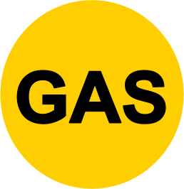 |  |  |  |  |  |  | Additional:
Electric |  | Pneumatic |  | Hydraulic |  | Water |  | Mechanical |  | Gas |  | Thermal |  | Stored Energy |  | Controlled Gravity

SECTION 4 – HAZARD IDENTIFICATION CHECKLIST (EVERY ITEM CHECKED SHALL BE ADDRESSED IN THE PRE-TASK PLAN)

 | Lockout / Tag out |  | Particles in Eyes |  | Manual Lifting |  | Confined Spaces |  | Cold Related Injuries
 | Electrical Shock |  | Elevated Work |  | Accessing and Egressing an AWP |  | High Noise Levels |  | Inhalation Hazard
 | Falling Objects |  | Mobile Equipment |  | Plant Ops impact |  | Chemical Spill |  | Other:
 | Lifting & Rigging |  | Ladders |  | Hot/cold Burns |  | Hazardous Chemicals |  | Other:
 | Equipment Loading / Unloading |  | Scaffolding |  | Asbestos |  | Safety Data Sheet |  | Other:
 | Fire / Explosion |  | Inadequate Access |  | Lead/Cadmium |  | Chemical Burns |  | Other:
 | Pinch Points |  | Excavations |  | Lighting |  | Radiation |  | Other:
 | Sharp Objects |  | Fall from Height |  | Isolated area |  | Heat Related Injuries |  | Other:

SECTION 5 – GENERAL PROJECT HAZARDS

Task/hazard: | Preventive measure: (If there is a Task/Hazard that is not applicable to this PTP, delete the preventive measure.
Review Of Daily Task Analysis | The foreman or supervisor, prior to the start of the task, will conduct a review of the Daily Task Analysis (DTA) with all workers involved. Personnel protective equipment (PPE) required for this task will be reviewed and discussed. Minimum PPE required is listed below in section 2-A-1 and other PPE may be required. All PPE will be inspected prior to use and all damaged PPE will be replaced. If the scope of work changes outside of what is in the DTA, the work is to be stopped and the DTA updated and all workers involved will review and sign-off prior to resuming the work.
Dehydration | Employees are reminded to stay fully hydrated throughout the day; water coolers and bottles are located throughout the jobsite for any employee to drink. Employees should watch out for other employees and look for signs of dehydration in themselves and others working around them.
Heat Related Injuries. | If you feel signs of heat stress coming on, let someone know and find somewhere out of direct sunlight to take a break and drink some water. Employees should watch out for other employees and look for signs of heat related injuries in themselves and others working around them.
Cold Related Injuries. | Dress appropriately for the conditions, layers of lightweight clothing keeps you warmer than a single layer of heavy cloths. Employees should watch out for other employees and look for signs of cold related injuries in themselves and others working around them.
Lockout / Tag out | Equipment will be locked out with keys placed in lockbox and tag fixed to the lock. Prior to entering worksite area, workers must place lock on lockbox and sign off on LOTO sheet. Workers must remove lock at end of shift. Locks will be verified prior to starting work, employees will initial LOTO sheet to verify. See attached LOTO log for equipment to be locked out.
Electrical Hazard | GFCI's must always be used to prevent accidental shock, GFCI must be plugged directly into the power source and not at the tool, inspect wires to ensure no tears, follow proper ECPL procedures.
Housekeeping | Continuously clean work areas to keep them free of trash and construction debris.
Lifting/Back & Muscle Strains | Employees must use proper lifting techniques (lift with legs, not back) when handling material. Material handling equipment, such as forklift or trolley shall be utilized to prevent back and muscle strain when pieces are too heavy to lift by hand.
Material Handling | Use proper PPE (suitable gloves) and lifting techniques (lift with legs not with back).
Pinch Points, Sharp Edges & Lacerations | Material will be unloaded from truck by hand. Abrasion resistant work gloves must be worn to protect employee's hands and fingers from pinch points and sharp edges. All mechanized equipment will be inspected prior to use.
Slips, Trips & Falls | Ensure proper housekeeping; maintain work area free of potential tripping hazards. Liquid spills must be reported and cleaned up immediately. Slip resistant work boots must be worn. Visually inspect work area prior to beginning work and familiarize yourself with existing trip hazards, such as anchors or piping.

Required Preventative Measures: | Training and Certifications as Required | Readiness for work | Proper PPE
(To be identified in the PTP) | (Records Available Upon Request) | (Stretching) | (Task Specific)

SECTION 6 – DETAILED JOB TASK, HAZARDS AND CONTROL MEASURES

Job Tasks  (What are the job tasks for completion?) | Potential Hazards  (What can go wrong? How can I be injured?) | Control Measures  (How do I eliminate or control the hazard?) | Contingency Plan  (What if?)
1. Main Activity Goes Here, the steps for this task are as follows.  Visit Area to Plan Project; Establish Lay-Down Area; Identify Routes for Tools/Material Delivery; Identify Evacuation Route & Assembly Area  Gather required permits and other required safety documentation from Safety.  Review Pre-Task Plan with crew. Review Daily Task Analysis – Work Permit with crew and discuss proper PPE.  Inspect work area for hazards, barricade working area, and stage tools and materials.  Task Specific Steps Go Here  Clean-up materials and properly dispose of construction debris, remove barricades, put tools and loose material away and demobilize from the area. | 1-A. Bodily injury or death due to inattentiveness.  1-B. Injury to eyes from flying debris or dust and particles.  1-C. Head injury from falling objects  1-D. Exposure to loud noises.  1-E. Struck by mobile construction equipment, construction vehicles or production.  1-F. Struck by improperly stored tools and materials.  1-G. Slips, trips and falls to the same elevation.  1-H. Miscommunication  1-I. Sprains and strains.  1-J. Cuts and abrasions.  1-K. Pinch points  Task Specific Hazards Begin Here. | 1-A-1. Walking and talking on any type of communication device is prohibited; This includes two way radios, walkie-talkies and cellular phones.  1-A-1. Operating any type of vehicle or equipment while on any type of communication device that is not hands free is prohibited; This includes two-way radios, walkie-talkies and cellular phones.  1-A-1. The use of ear buds (Bluetooth) and headphones is not permitted anywhere in the shop  1-A-1. The use of ear buds (Bluetooth) and headphones is not permitted in any area where there is mobile equipment operation or vehicular traffic such as but not limited to, loading offloading areas and parking lots.  1-A-1. Cell phone usage is restricted to designated break areas only.  1-A-1. No personal radios, MP3 players, Walkman, or CD players of any kind are allowed in the shop.  1-B-1. ANSI Z-87.1 approved safety glassed will be worn from the time you enter the turnstile.  1-B-2. Hardhats can only be removed in a designated break area.  1-B-3. Mono-goggles will be worn when working overhead or in windy conditions.  1-C-1. Approved hardhats will be worn from the time you enter the turnstile to the time you exit the turnstile.  1-C-2. Hardhats can only be removed in a designated break area.  1-D-1. Hearing protection must be worn in areas where personnel are exposed to noise levels in excess of 90 decibles.  1-E-1. Approved hi-visibility reflective vest shirt or jacket will be worn from the time you enter the turnstile to the time you exit the turnstile.  1-E-2. Use spotter for all equipment movement.  1-E-3. Operators must check for clearance.  1-E-4. Operators shall observe the posted speed limits outside of building footprint.  1-E-5. All operators will observe 5 mph speed limits inside of the building.  1-E-6. Do not stand on the side steps of equipment while talking to the operator.  1-E-7. Maintain an 8-foot safety around all equipment.  1-E-8. Stay clear of production traffic areas if at all possible.  1-F-1. Oversized tools and material, such as ladders and pipes are not to be stored leaning against walls or columns.  1-F-2. Items such as ladders shall be stored lying down in a designated area.  1-F-3. All material such as piping, wood and all-thread, shall be stored on a pallet, on dunnage or on a material rack.  1-G-1. Maintain awareness of your surroundings.  1-G-2. Keep aisle ways and work areas free of tools, material and debris.  1-G-3. When using the stairs, ensure that the handrails are used at all times going up and down the stairs.  1-G-4. Ensure all holes bigger than two inches in diameter are covered. If holes need to be covered contact Safety and suspend work in the area if employees cannot be adequately safeguarded from the opening.  1-G-5. Ensure hole covers are secured to prevent accidental movement and that they are visibly marked as a hole.  1-G-5. No rolling stock on the floor or leaning against walls or columns. All material shall be stored on a pallet, on dunnage or on a material rack.  1-H-1. The PTP at a minimum shall be reviewed once at the beginning of the task, and again if changes are made to the scope of work, work method or work area. New employees hired after the initial review shall review it as well  1-H-2. Ensure that all employees are cognizant during the review of the PTP and fully understand the task and the safety requirements.  1-H-3. The DTA at a minimum shall be reviewed at the beginning of the shift, changes are made to the scope of work, work method or work area. Employees who arrive after the initial review shall review the DTA as well.  1-H-4. Ensure that all employees are cognizant during the review of the DTA and fully understand the task and the safety requirements.  1-H-5. The PTP and DTA should coincide with one another, as the PTP should be referenced to write the DTA.  1-H-6. Supervisors and Foreman need to visually verify that all of their employees have the proper PPE prior to the start of the task. The minimum required PPE will be hard hats, safety glasses, task specific gloves, hi-visibility reflective vest, and construction grade work boots that cover the ankle. Additional PPE may consist of but will not be limited to hearing protection.  1-I-1. Never lift or move objects by hand that are too heavy or awkward, If the load is too heavy get help or use mechanical means of lifting.  1-I-2. Get as close to the load as possible when lifting.  1-I-3. Use a wide stance with one foot slightly ahead of the other.  1-I-4. Lift with your legs, by bending your knees not your back.  1-I-5. Keep your back straight while lifting. Never twist your back while lifting, pick up your feet to turn.  1-I-6. Lower the load slowly and keep it under control.  1-J-1. Abrasion resistant gloves must be worn to minimize the probability of lacerations.  1-K-1. Maintain proper hand and body placement in relation to your work and your surroundings.  1-K-2. Be aware of your surroundings and have a pre-determined escape route should the need arise.  1-K-3. Use proper tool for job that fits properly and is in its intended position.  Task Specific Corrective Measures Being Here. | CONTRACTOR SAFETY NUMBERS:  SAFETY NUMBERS:  Name:  Title:  Phone:  Email:  Name:  Title:  Phone:  Email:  Name:  Title:  Phone:  Email:  CONTACT NUMBERS:  Security:  Safety:  Site Safety:  URGENT CARE PROVIDERS:  1. In the event that employees fail to follow the procedures outlined in the pre-task analysis, those employees will be subject to Disciplinary policies. Continued disregard for company safety policies could result in the removal of an employee for a period of time or permanently.  2. All injuries, accidents, work related illnesses, incidents, chemical spills & near misses must be reported to the .  3. In the event of an injury, accident, work related illness, incident, chemical spill or near miss all employees associated with the event are to stop working immediately, and that nothing is to be moved or removed from the area of the event.  4. In the event of a near miss contact Safety.  5. In the event of Property Damage contact Safety.  6. In the event of a chemical spill contact Safety.  7. In the event of a first aid injury contact Safety.  8. In the event of an emergency contact 911, provide them with your name, the name of the injured employee, the location (use column numbers). DO NOT HANG UP UNTIL INSTRUCTED TO DO SO. Then contact Safety.  9. Failure to report an injury, accident, work related illness, incident, chemical spill or near miss in a timely manner, is grounds for removal from the site.  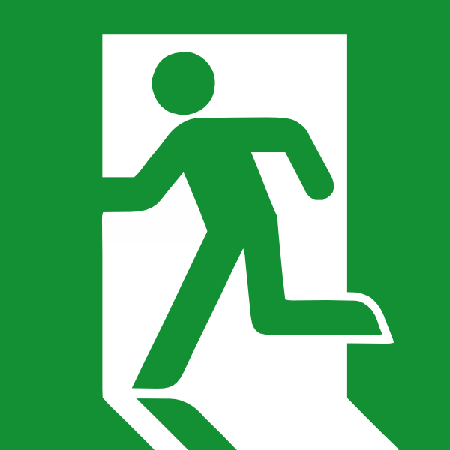  10. In the event of a building evacuation all employees shall, in an orderly manner, proceed to the nearest exit and then to the assembly point located at the location below:  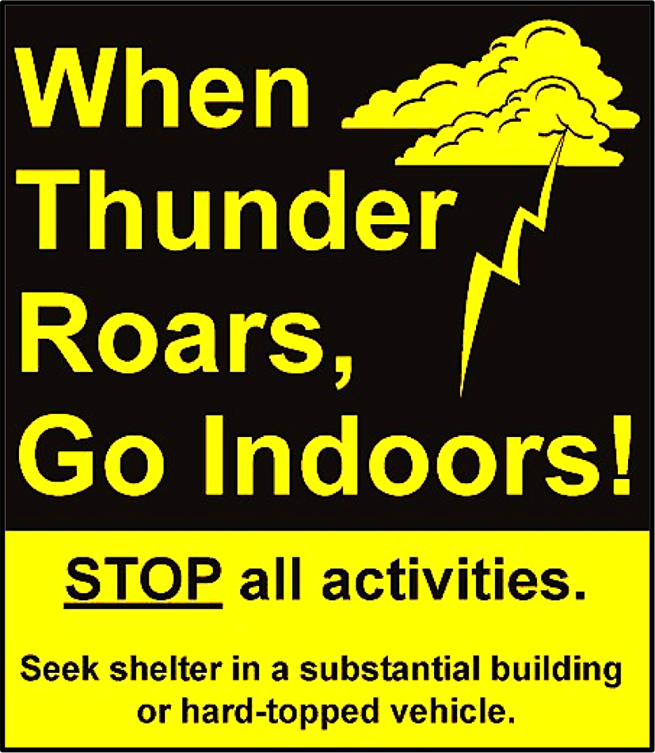  12. Lightning alerts will be issued when lightning is within 10 miles of the facility. All outside work must stop and all employees shall take shelter in the building. Employees are not to be outside for any reason while under a lightning alert.  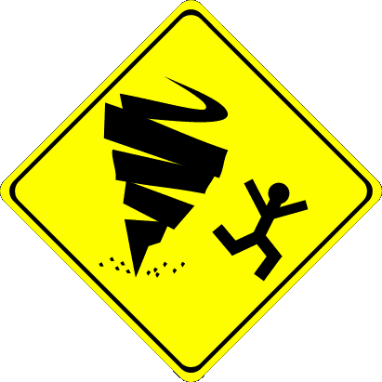  11. In the event of severe weather all employees shall, in an orderly manner, proceed to the nearest severe weather shelter. Shelters are located at the following column numbers:  Superintendent and Foremen will account for all of their employees.

DO NOT EXCEED THE SCOPE OF THIS PRE-TASK PLAN!
As the job progresses and the scope of the work exceeds the boundary of the Pre Task Plan (PTP) STOP! The PTP must be updated, these updates can be made in the field in writing by the foreman or supervisor, however a copy needs to be turned into safety so the changes can be added to the PTP on file.

SECTION 7 – REVISIONS TO PRE TASK PLAN (CHANGES CAN BE WRITTEN, HOWEVER A COPY NEED TO BE TURNED IN TO THE SAFETY OFFICE SO THE CHANGES CAN BE ADDED TO THE PTP ON FILE.)

Company: |  | Location: |  | Date:
Main Activity: |  | Duration: |  | Changes By:

Job Tasks  (What changed or was added in the job tasks?) | New Potential Hazards:  (What can go wrong? How can I be injured?) | New Hazard Solution:  (How do I eliminate or control the hazard?) | Contingency Plan  (What if?)

DO NOT EXCEED THE SCOPE OF THIS PRE-TASK PLAN!
As the job progresses and the scope of the work exceeds the boundary of the Pre Task Plan (PTP) STOP! The PTP must be updated, these updates can be made in the field in writing by the foreman or supervisor, however a copy needs to be turned into safety so the changes can be added to the PTP on file.

SECTION 7 – REVISIONS TO PRE TASK PLAN (CHANGES CAN BE WRITTEN, HOWEVER A COPY NEED TO BE TURNED IN TO THE SAFETY OFFICE SO THE CHANGES CAN BE ADDED TO THE PTP ON FILE.)

Company: |  | Location: |  | Date:
Main Activity: |  | Duration: |  | Changes By:

Job Tasks  (What changed or was added in the job tasks?) | New Potential Hazards:  (What can go wrong? How can I be injured?) | New Hazard Solution:  (How do I eliminate or control the hazard?) | Contingency Plan  (What if?)

DO NOT EXCEED THE SCOPE OF THIS PRE-TASK PLAN!
As the job progresses and the scope of the work exceeds the boundary of the Pre Task Plan (PTP) STOP! The PTP must be updated, these updates can be made in the field in writing by the foreman or supervisor, however a copy needs to be turned into safety so the changes can be added to the PTP on file.

SECTION 8 – PPE, SPECIAL EQUIPMENT AND PERMITS

 |  |  |  |  |  |  |  |  |  |  |  |  |  |  |  |  |  |  |  |  |  |  |  | With Side Shields
 |  |  |  |  |  |  |  |  | 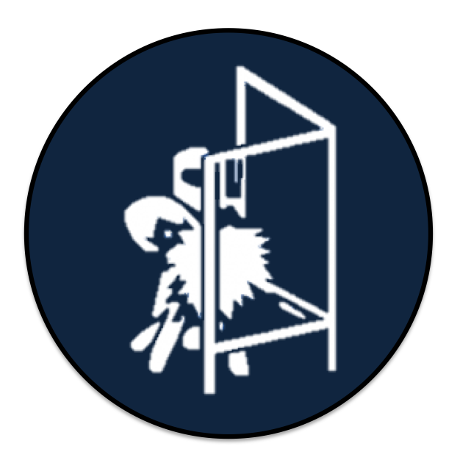 |  | 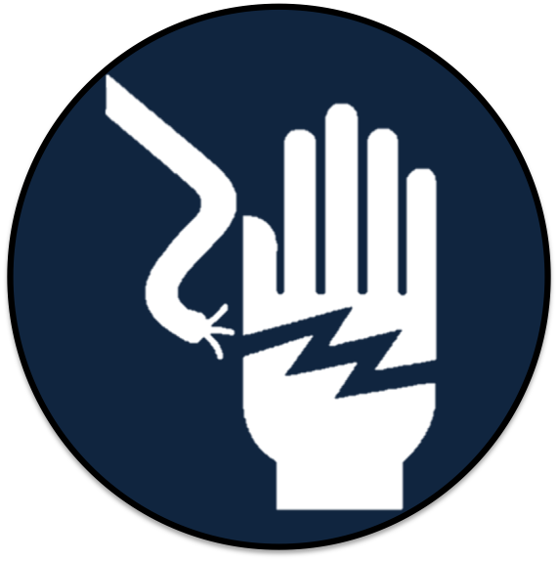 |  |  |  | 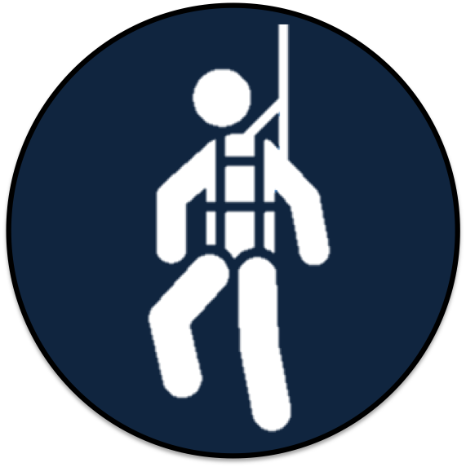 |  | 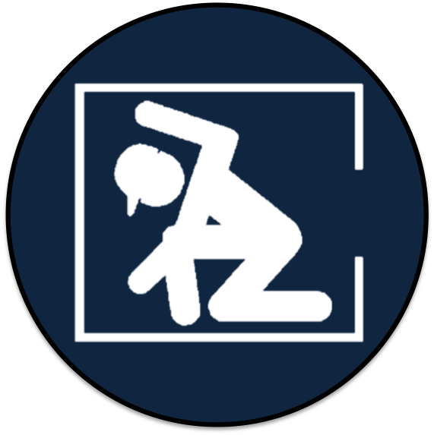 |  |  |  | 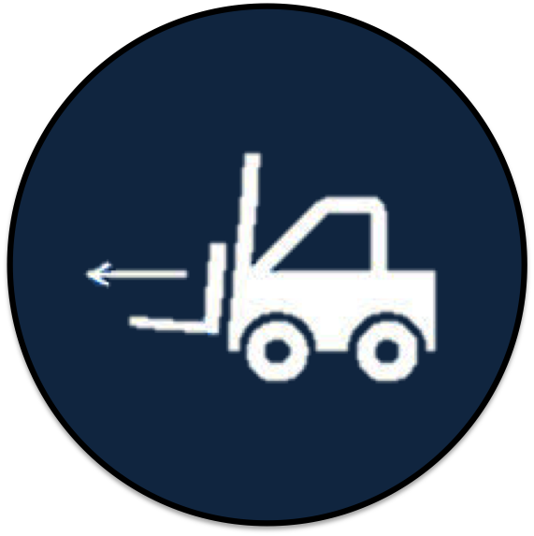 |  |  |  | Crane
 |  |  |  |  |  |  |  |  |  |  |  |  |  |  |  |  |  |  |  |  |  |  |  |  | Chain
 |  |  |  |  |  |  |  |  |  |  |  |  |  |  |  |  |  |  |  |  |  |  |  |  | Falls

Thermal protection Arc Flash protection Other:
Special Equipment? (EWP, mobile crane, bucket truck, boom truck, forklifts, etc.):
Special Permit? (NCCCO, EWP Operator Permit, Fork Lift Permit all current etc.):

All Ground Observers for EWP’s will have a current operator card for EWP’s from the company being worked for, or from a 3rd party source such as a vendor, or from their union hall.

SECTION 9 – NOTIFICATIONS AND EMERGENCY RESPONSE CONTACTS AND PROCEDURES

Emergency Plan Notifications  (Who should be notified - list names & Numbers) | Emergency Plan  (List special procedures)
 | - In the event of a near miss, contact Immediately.
 | - In the event of a Property Damage event, contact Immediately.
 | - In the event of a chemical spill, contact Immediately.
 | - In the event of a first aid injury, render the required first aid and contact Immediately.
 | - In the event of an emergency contact 911. Provide them with your name, the name of the injured employee, the location
 | (use column numbers). DO NOT HANG UP UNTIL INSTRUCTED. Then contact .
 | All outside work will be shut down if lightning is reported within 10 miles of the plant.

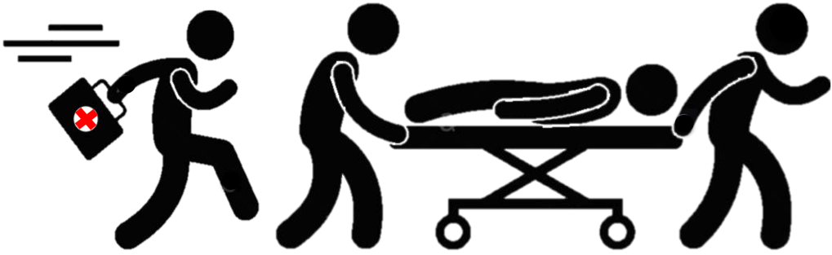 | All injuries, accidents, work related illnesses, incidents, chemical spills & near misses must be reported immediately. | 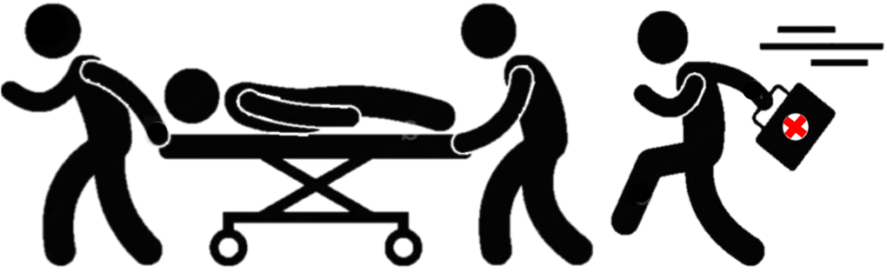

SECTION 10 – EMPLOYEE REVIEW OF PRE-TASK PLAN
Supervisor Conducting Briefing:
Name | Signature | Date | Name | Signature | Date

I understand that by signing this sheet I acknowledge that I understand todays task, associated hazards and corrective measures needed to protect myself and that I will abide by the contents.

SECTION 11 – SAFETY WORK ZONES, SENTINEL EVENTS AND CONTRACTORS PRE-TASK PLAN SUBMITTAL AND REVIEW FORM:

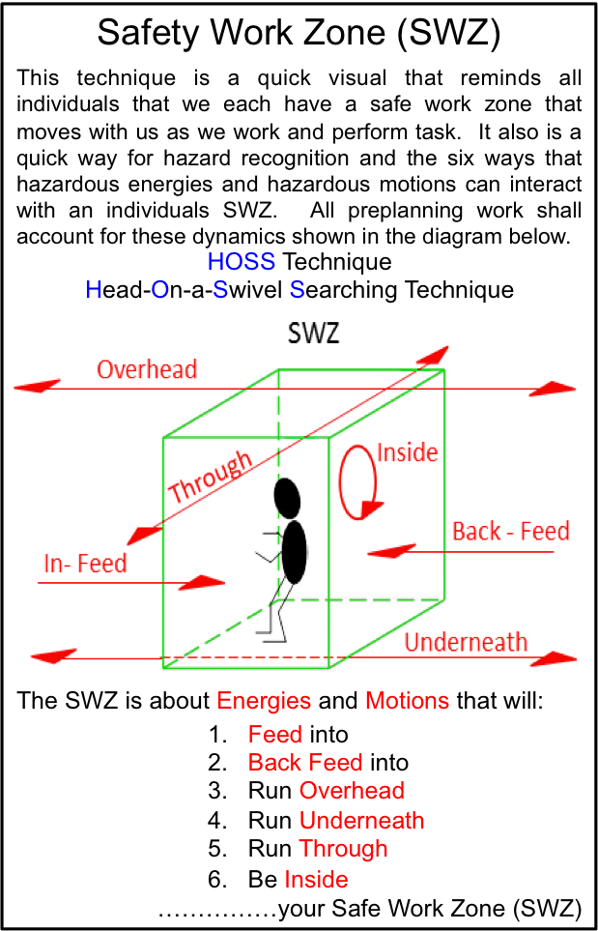 | - Sentinel Event: Is and observation, near miss or accident that should or could kill you or one of your workers. Report all sightings!!!
- Mobile Equipment Safety Zones eight (8) feet around any equipment with an operator in it. Twenty (20) plus around any up loading and down loading equipment.
- Face Shields and safety glasses will be worn when using right angle grinders, power circular saws, and chippers.
- Guards shall not be removed from equipment.
- Dark tinted glasses shall not be worn in low light.
- Do not weld or cut without non-flame retardant apparel.
- Any power tool needing a wheel, saw blade, or bit changed, will be unplugged first!!!
- No rolling stock on floor or leaning against walls or beams (Must be on Pallets, Dunnage or Racks.

- A Pre Task Plan is a living document, should the scope of work exceed the PTP then the work should halt, adjustments should then be made to the PTP to reflect actual scope of work. Once the PTP is updated it SHALL be reviewed with the entire crew

Initial Review:

Customer Safety Reviewed By: |  | Comments: |  | Date:
Dürr Safety Reviewed By: | 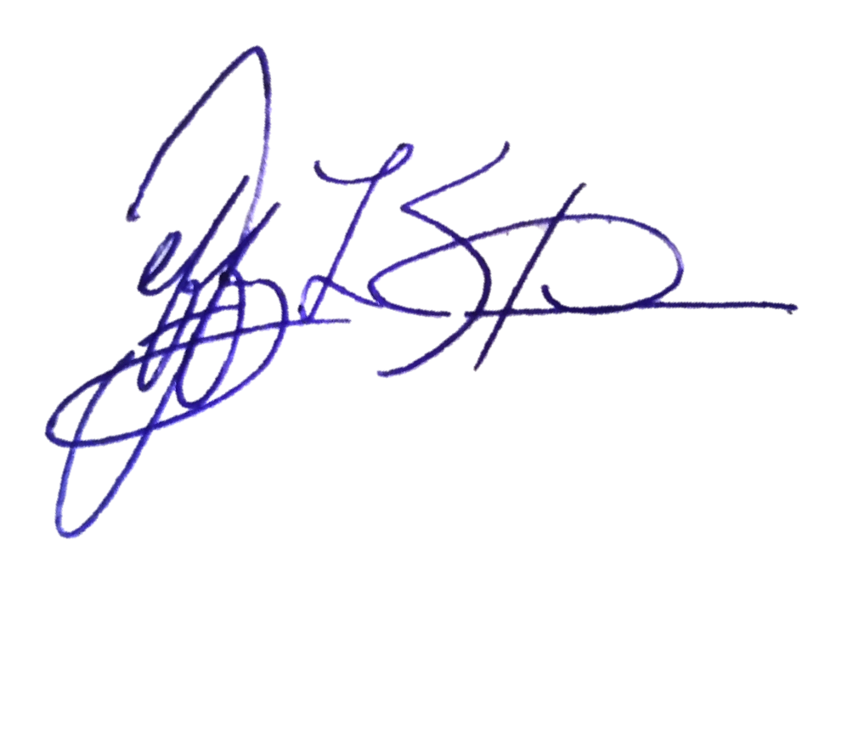 | Comments: |  | Date:
Sub-Contractor Reviewed By: |  | Comments: |  | Date:

**If your Work Plan changes, the PTP needs to be modified to reflect those changes**

SECTION 12 – USE THIS SECTION TO DIAGRAM ANY OVERHEAD WORK COVERED UNDER THIS DTA. INCLUDE YOUR BARRICADE PLAN.
DATE:
NAME:
SIGNATURE: |  |  |  |  |  |  |  |  |  |  |  |  |  |  |  |  |  |  |  |  |  |  |  |  |  |  |  |  |  |  | PAGE_____OF_____

